Project 2: Report

# 1. Maze Description: Design your grid world example and describe it at the beginning of the report.

A: Maze Design:

Maze consist of 5 rows and 4 columns with 2 walls

2. Problem Formulation: Define your states, actions, and rewards.

A: States:

* + Initial: on co-ords (3,0) which is in yellow colour.
  + Goal: in (0,4) which is in green colour.

Action:

There are four actions at every state.

* + Up
  + Down
  + Left
  + Right

Rewards:

* + Step: 0
  + Wall: -5
  + Goal: 10

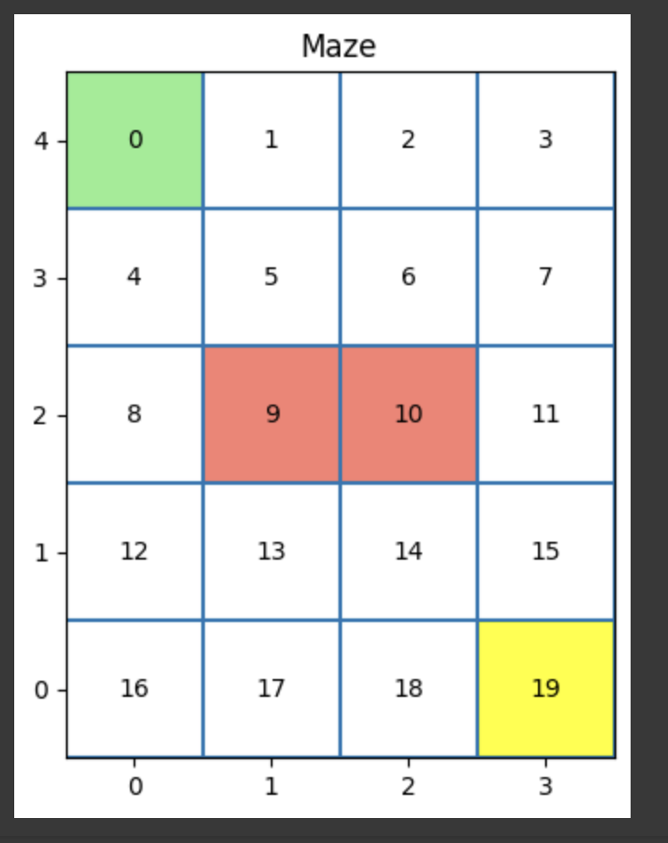

3. Q Network Design: Design and implement your Q network.

A:

## Q Network Design:

There are four layers in Q network.

* Layer 1: Input Layer: 2 nodes, which take (x,y) coordinates as input.
* Layer 2: Hidden Layer: 150 nodes.
* Layer 3: Hidden Layer: 100 nodes.
* Layer 4: Output Layer: 4 nodes, each correspondence to each action

With learning rate = 1e-3 and adam optimizer is used.

## Implementation:

This model is implemented in the function “update_Q_table_Q_Network”. In the below line.

new_state_Q_values = self.model(torch.from_numpy(np.array([new_state_x, new_state_y])).float())

Which returns 4 outputs, which are the Q values for each action. For that, the Q values of each action will fetch the maximum of Q values and updates the Q table.

4. Pseudo Code: Provide the pseudo-code in the report.

A: For each episode, the model will evaluate and generate the 4 Q values for each action, taking the position of the new state as input.

Update_Q_table_Q_Network function helps us to update the Q table using the neural network model and return the loss.

def update_Q_table_Q_Network(self, new_state: int):

"""

Function that applies the RL update function

"""

# Getting the next_state's reward

reward = self.reward_dict[new_state]

# Saving the current Q value

current_Q = self.Q[self.past_state][self.past_action]

# If the new state is the terminal state or the wall state, then the max_Q is 0

max_Q = 0

Y = reward

# Else we get the max Q value for the new state

if new_state != self.goal_state:

with torch.no_grad():

new_state_x, new_state_y = self.get_state_coords(new_state)

new_state_Q_values = self.model(torch.from_numpy(np.array([new_state_x, new_state_y])).float())

max_Q = torch.max(new_state_Q_values) #M

Y = reward + (self.gamma * max_Q)

# Updating inplace the Q value

self.Q[self.past_state][self.past_action] = current_Q + self.alpha * (reward + self.gamma * max_Q - current_Q)

Y = torch.Tensor([Y]).detach()

X = torch.from_numpy(self.Q[self.past_state]).squeeze()[self.past_action]

loss = self.loss_fn(X, Y) #P

clear_output(wait=True)

self.optimizer.zero_grad()

loss = Variable(loss, requires_grad = True)

loss.backward()

self.optimizer.step()

return loss

Model code:

l1 = 2

l2 = 150

l3 = 100

l4 = self.num_actions

self.model = torch.nn.Sequential(

torch.nn.Linear(l1, l2),

torch.nn.ReLU(),

torch.nn.Linear(l2, l3),

torch.nn.ReLU(),

torch.nn.Linear(l3,l4)

)

Training episodes code:

def train_episodes_Q_Network(self, num_episodes: int):

"""

Function that trains the agent for one episode

"""

# Calculating the episode number to end the training

end_episode = self.current_episode + num_episodes - 1

# Creating a dir to store the images

os.makedirs(self.path_to_images_V, exist_ok=True)

os.makedirs(self.path_to_images_Q, exist_ok=True)

# If the directory for the first episode is not empty, we delete the files inside it

if len(os.listdir(self.path_to_images_V)) > 0:

for file in os.listdir(self.path_to_images_V):

os.remove(os.path.join(self.path_to_images_V, file))

if len(os.listdir(self.path_to_images_Q)) > 0:

for file in os.listdir(self.path_to_images_Q):

os.remove(os.path.join(self.path_to_images_Q, file))

episode_weights = {}

# Moving the agent until we reach the goal state

while self.current_episode != end_episode:

print(f"Episode {self.current_episode}")

print(self.reward_dict)

self.move_agent_Q_Network(num_episodes)

plot_V_Table(

S=self.S,

Q=self.Q,

goal_coords=self.goal_coords,

wall_coords=self.wall_coords,

start_coords=self.start_coords,

title=f"V Table at Episode {self.current_episode}",

filename=f"{self.path_to_images_V}/episode_{self.current_episode}.png"

)

plot_Q_Table(

S=self.S,

Q=self.Q,

goal_coords=self.goal_coords,

wall_coords=self.wall_coords,

start_coords=self.start_coords,

title=f"Q Table at Episode {self.current_episode}",

filename=f"{self.path_to_images_Q}/episode_{self.current_episode}.png"

)

self.capture_weight_stats()

5. Results and Discussions: Show the convergence process of mean square error (objective  
function) and the weights trajectories.

**Loss Function:**

6. Reference: cite all your references here.

<https://towardsdatascience.com/part-2-building-a-deep-q-network-to-play-gridworld-catastrophic-forgetting-and-experience-6b2b000910d7>

<https://github.com/Eligijus112/rl-snake-game>